132÷12 | 120÷12 = | 84÷12 = | 36÷12 = | 96÷12 =
144÷12 = | 12÷12 = | 72÷12 = | 60÷12 = | 48÷12 =
36÷12 = | 24÷12 = | 96÷12 = | 108÷12 = | 12÷12 =
72÷12 = | 24÷12 = | 12÷12 = | 144÷12 == | 84÷12 =
60÷12 = | 48÷12 = | 132÷12 = | 120÷12 = | 36÷12 =
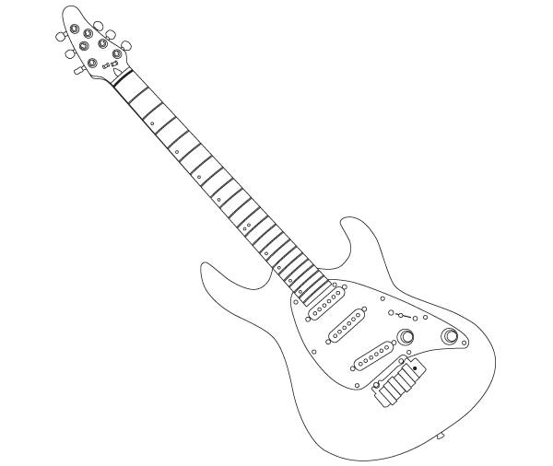

Can you improve your time?

Time!

How did you get on?

score

Dougie says…

Try these at home
÷ 12
Can you improve your
Score?

Name:
Date:

