11÷11 = | 44÷11 = | 121÷11 = | 77÷11 = | 66÷11 =
77÷11 = | 22÷11 = | 55÷11 = | 44÷11 = | 99÷11 =
22÷11 = | 99÷11 = | 11÷11 = | 132÷11 = | 121÷11 =
55÷11 = | 66÷11 = | 33÷11 = | 99÷11 = | 33÷11 =
110÷11 = | 88÷11 = | 11÷11 = | 55÷11 = | 88÷11 =
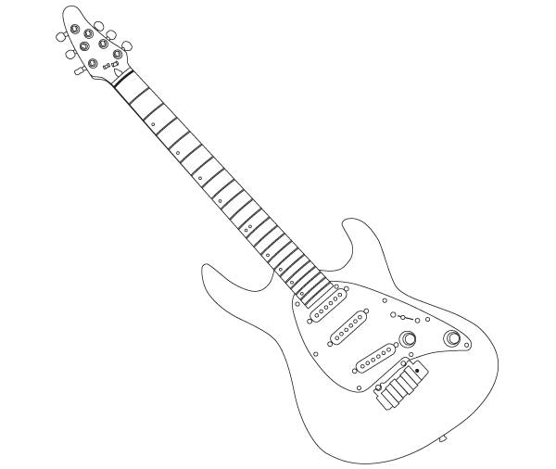

Can you improve your time?

Time!

How did you get on?

score

Prince says…

Try these at home
÷ 11
Can you improve your
Score?

Name:
Date:

