Content’s Page

|  |  |
| --- | --- |
| **Page** | **Activity** |
| 1,2 | Wellbeing Warrior Introduction |
| 3 | I am looking forward to…. |
| 4 | Activity Log |
| 5 | My ideas |
| 6,7 | All the different emotions emojis |
| 8 | I’m Excited |
| 9 | I’m Sad |
| 10,11,12 | Our own Characters |
| 13 | What are these characters feeling? |
| 14 | Days of the feels calendar |
| 15 | Messages of Kindness |
| 16 | Being kind to yourself |
| 17 | Breathing with Colour |
| 18 | Understanding Feelings |
| 19 | Understanding Others |
| 20 | How can I help? |
| 21 | Staying Connected |
| 22 | Wordsearch |
| 23,24 | Note Page |

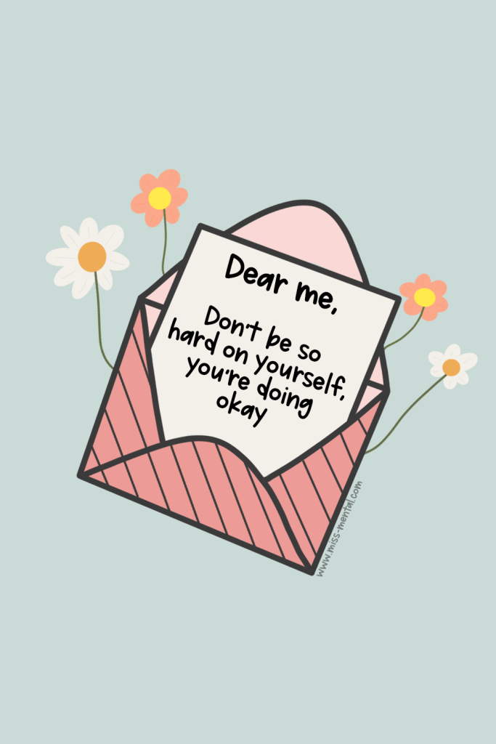**Wellbeing Warriors**

Hello everyone! Welcome to Wellbeing Warriors! Wellbeing is a really important idea that covers lots of different things like our physical, emotional, mental, and social health. It’s totally okay not to feel happy all the time—feeling sad, frustrated, or scared is part of being human! These feelings help us learn and grow.

Wellbeing is all about discovering ways to handle our emotions in a positive way. In Wellbeing Warriors, we’ll have a fun and friendly space to learn about wellbeing, make friends, and understand how to cope with our feelings better at school.

As members of Wellbeing Warriors, we get to be leaders, helpers, and role models for younger students and our peers. Through exciting activities, we can learn more about our own wellbeing and how we can support others. It’s important to show kindness, help solve problems, and practice good wellbeing habits. Together, we can make our school a happier place for everyone! Let’s go on this amazing journey to better wellbeing together!

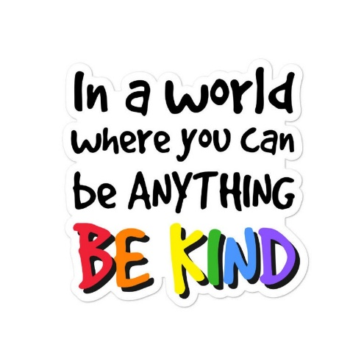

We wear these badges with pride, showing that kindness is our superpower. In a world where you can be anything, choose to be kind! Together, we create a happy, friendly space where everyone feels valued and loved. Let’s spread joy and make a difference!

As Wellbeing Warriors, we know how vital it is to support each other, and that's why we regularly empty the worry monster's mouth. This means that we listen to any worries our peers might have and do our best to help ease their concerns.

If at any time we feel worried or if we hear someone else is feeling down, we make sure to share our concerns with Mrs. Willis, our Pastoral Lead. She has a special role in helping us and our friends feel better.

Additionally, we meet with Mrs. Willis to receive training on how to support children's wellbeing effectively. This training teaches us new skills and techniques that enable us to be even better at looking after one another. It's important to understand how to approach different situations with kindness and empathy.

Together, as Wellbeing Warriors, we create a supportive and caring environment where everyone feels valued and heard. Let's continue to be friends and champions for mental wellbeing!

# I am looking forward to…….

# Activity log

Use this space to log the activities you undertake as a wellbeing warrior.

|  |  |
| --- | --- |
| Date | Activity |
|  |  |
|  |  |
|  |  |
|  |  |
|  |  |
|  |  |
|  |  |
|  |  |
|  |  |
|  |  |
|  |  |
|  |  |
|  |  |

My ideas to help the wellbeing of others are…….



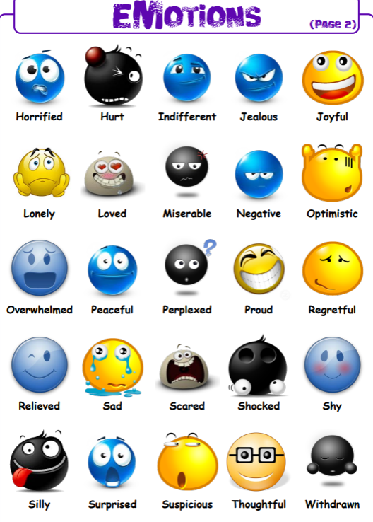

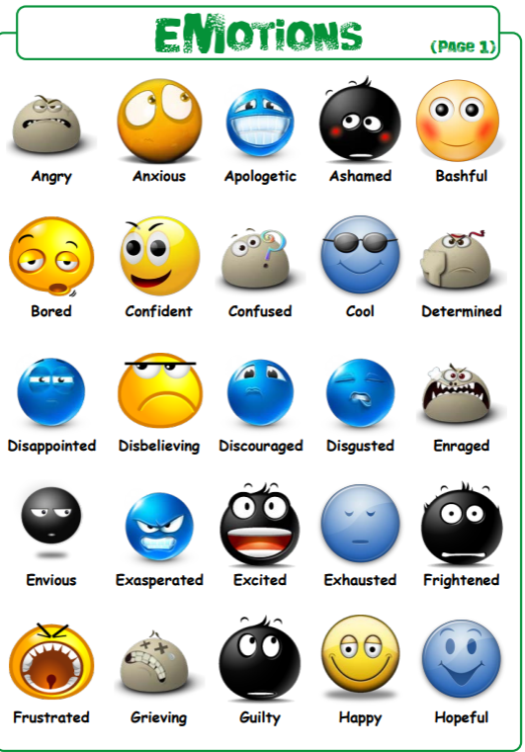

Can you create characters that’s depict feelings and write as many words as possible that mean that feeling? eg

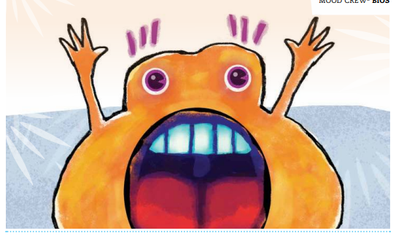



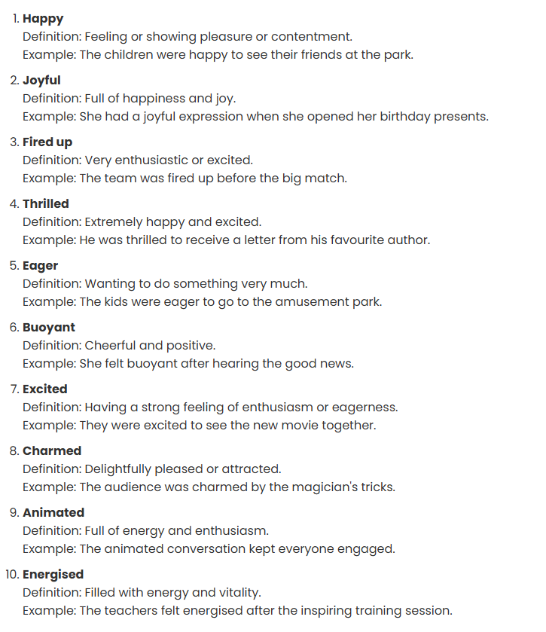

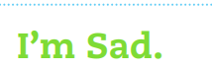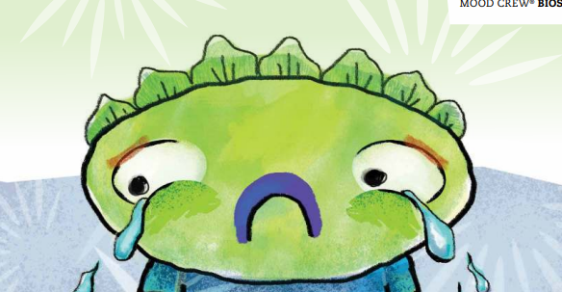

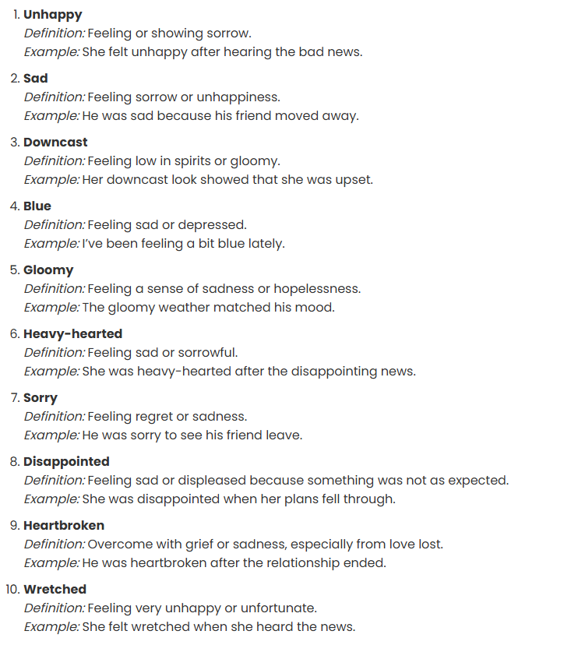

Feeling___________________

Associated Words

Feeling_________________

Associated Words

Feeling___________________

Associated Words

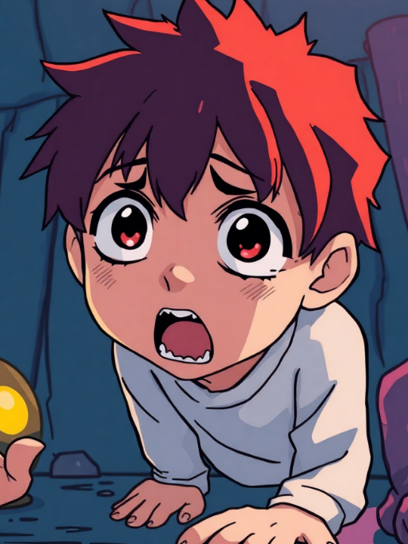What do you think these characters are feeling?

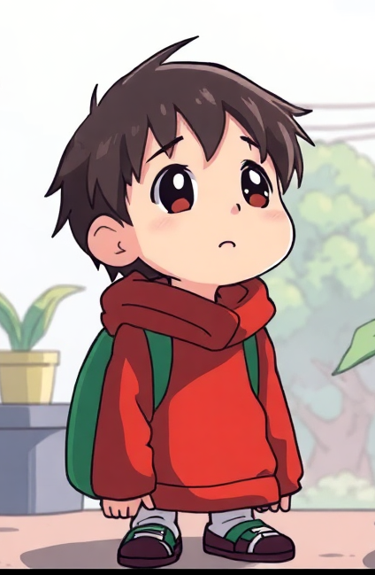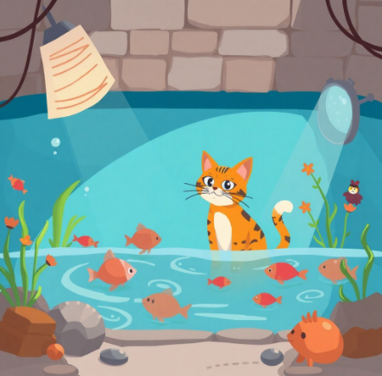

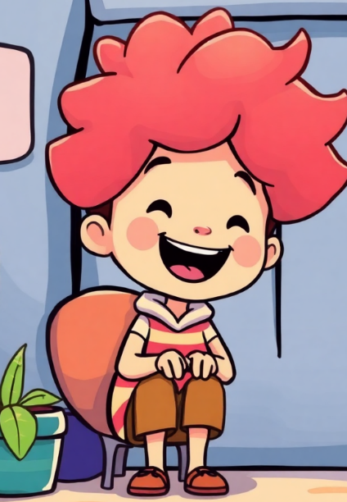



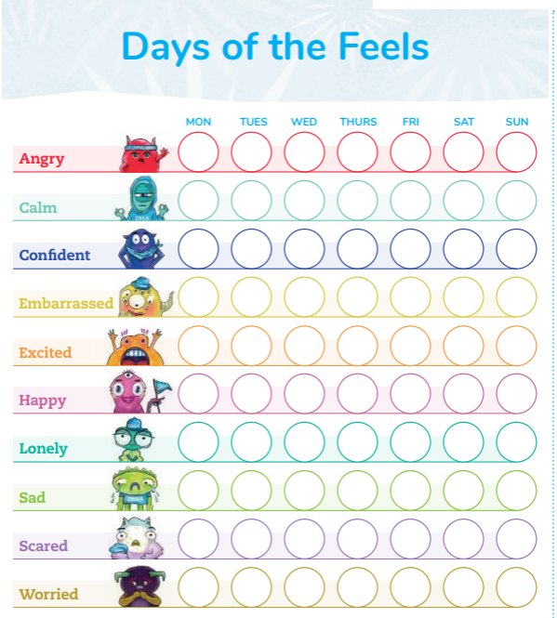

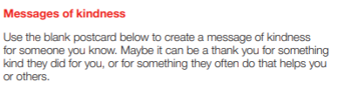



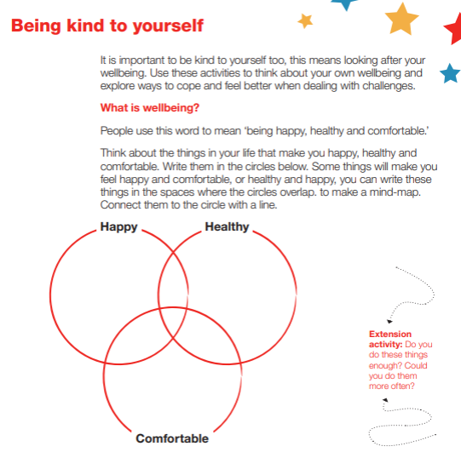

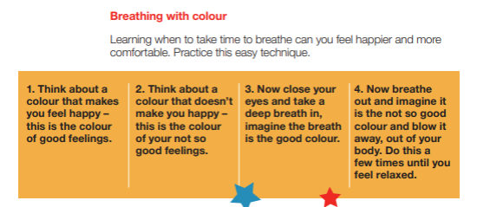

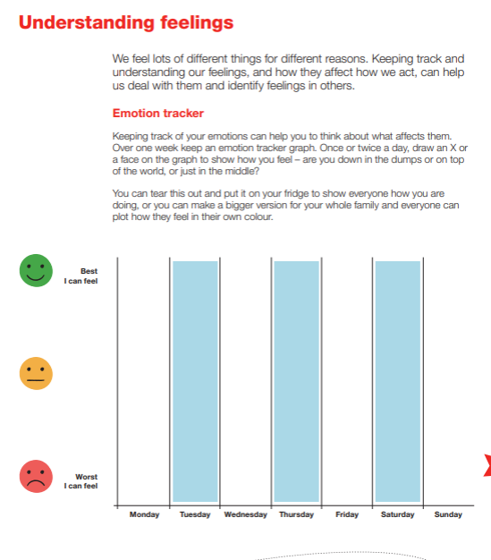

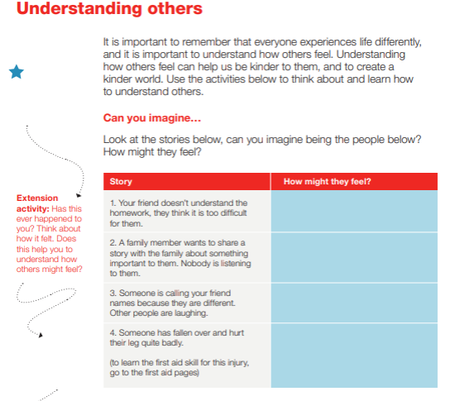

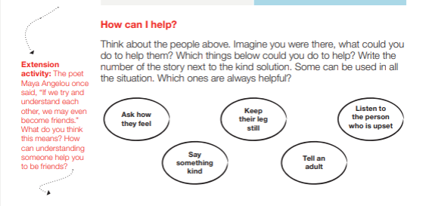

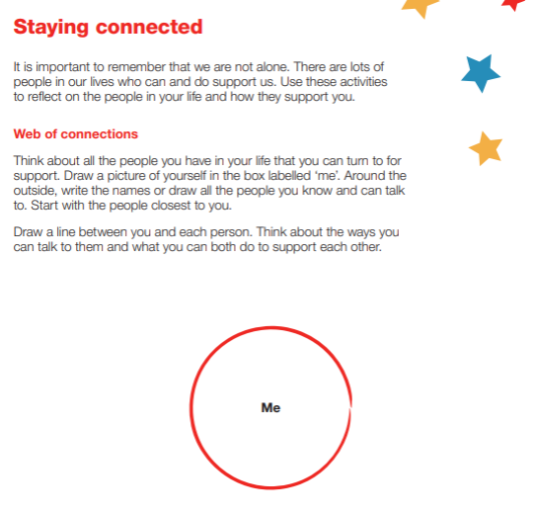

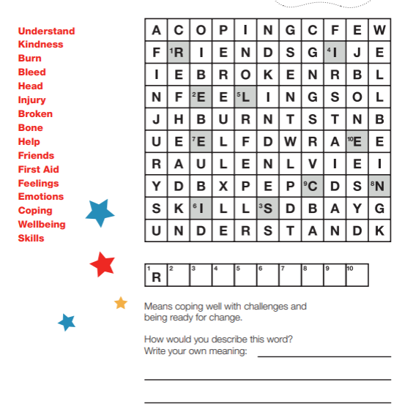

Note Page