21 ÷ 3 = | 24 ÷ 3 = | 36 ÷ 3 = | 30 ÷ 3 = | 21 ÷ 3 =
27 ÷3 = | 18 ÷ 3 = | 9 ÷ 3 = | 33 ÷ 3 = | 12 ÷ 3 =
6 ÷3 = | 3 ÷ 3 = | 24 ÷ 3 = | 15 ÷ 3 = | 33 ÷ 3 =
36 ÷ 3 = | 15 ÷ 3 = | 18 ÷ 3 = | 9 ÷ 3 = | 6 ÷ 3 =
30 ÷ 3 = | 12 ÷ 3 = | 27 ÷ 3 = | 21 ÷ 3 = | 27 ÷ 3 =
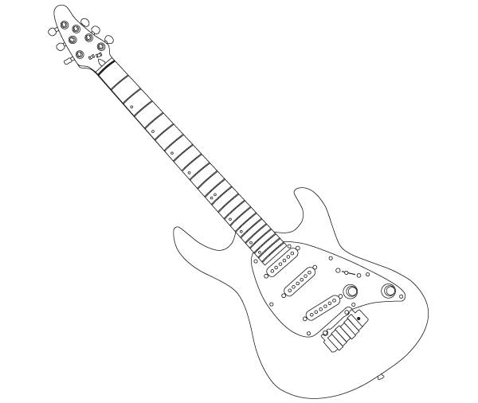

Time!
Try these ÷3 at home!
3 x
Can you improve your time?

Can you improve your
Score?

L’il Keeshasays…
Name:
Date:
Go tell your teacher how well you did!

