4 X 11 = | 110 ÷ 11 = | 11 X 12 = | 8 X 11 = | 99 ÷ 11=
11 X 3 = | 88 ÷ 11 = | 132 ÷ 11= | 33 ÷ 11 = | 11 X 7 =
33 ÷ 11 = | 11 X 6 = | 66 ÷ 11= | 44 ÷ 11= | 11 ÷ 11=
11 X 11 = | 11 X 2 = | 11 X 10 = | 132 ÷ 11= | 22 ÷ 11 =
77 ÷ 11= | 55 ÷ 11 = | 5 X 11 = | 11 X 9 = | 121 ÷ 11 =
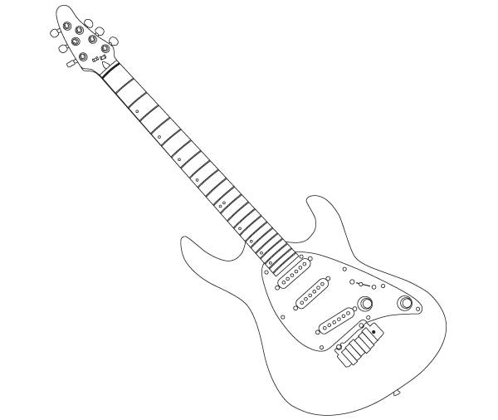

Can you improve your time?

Time!

How did you get on?

score

Prince says…

Try these at home
x 11 mixed
Can you improve your
Score?

Name:
Date:

