4 X 10 = | 100 ÷ 10 = | 12 X 10 = | 8 X 10 = | 90 ÷ 10=
3 X 10 = | 80 ÷ 10 = | 120 ÷ 10= | 30 ÷ 10 = | 7 X 10 =
30 ÷ 10 = | 6 X 10 = | 60 ÷ 10= | 40 ÷ 10= | 10 ÷ 10=
11 X 10 = | 2 X 10 = | 10 X 10 = | 120 ÷ 10= | 20 ÷ 10 =
70 ÷ 10= | 50 ÷ 10 = | 5 X 10 = | 9 X 10 = | 110 ÷ 10 =
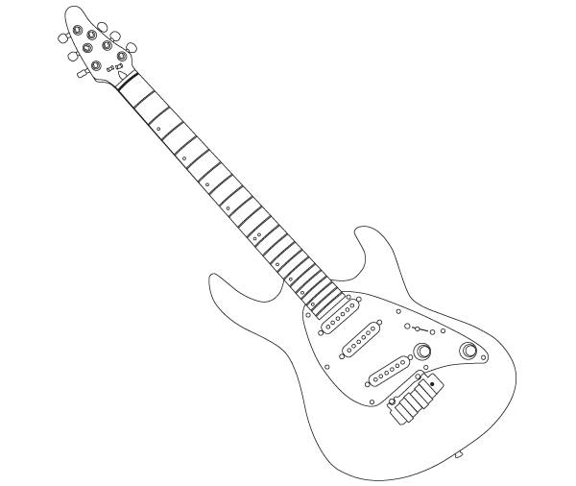

Time!
Can you improve your time?

Can you improve your
Score?

Try these at
HOME
x÷10

OZZIE says…
Name:
Date:
Go tell your teacher how well you did!
Score:

