55÷5 = | 45÷5 = | 60÷5 = | 60÷5 = | 25÷5 =
10÷5 = | 40÷5 = | 50÷5 = | 20÷5 = | 15÷5 =
25÷5 = | 5÷5 = | 15÷5 = | 35÷5 = | 45÷5 =
40÷5 = | 30÷5 = | 55÷5 = | 20÷5 = | 10÷5 =
50÷5 = | 10÷5 = | 35÷5 = | 15÷5 = | 30÷5 =
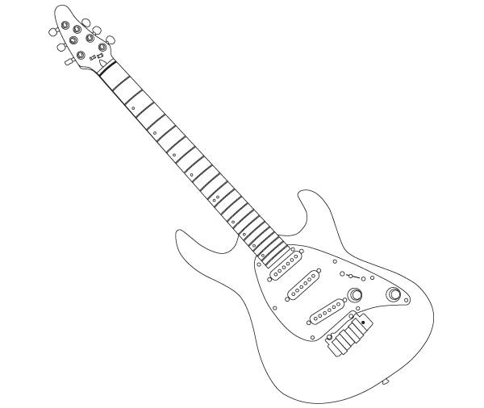

Time!
Can you improve your time?

Can you improve your
Score?

pete says…
Try these at
HOME
÷ 5

Name:
Date:
Go tell your teacher how well you did!
Score:

