12÷6 = | 72 ÷ 6 = | 54÷6 = | 12÷6 = | 48÷6 =
36÷6 = | 6÷6 = | 30÷6 = | 30÷6 = | 66÷6 =
66÷6 = | 42÷6 = | 36÷6 = | 60÷6 = | 54÷6 =
48÷6 = | 42÷6 = | 18÷6 = | 24÷6 = | 24÷6 =
24÷6 = | 12÷6 = | 72÷6 = | 18÷6 = | 36÷6 =
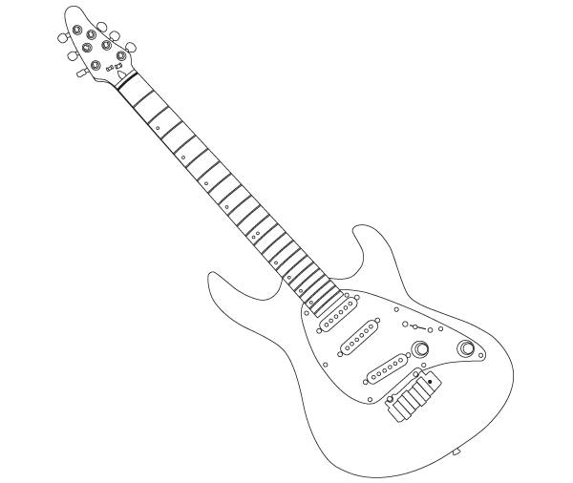

Time!
Can you improve your time?

Can you improve your
Score?

Jess says…
Try these ÷6 at Home!

Name:
Date:
Go tell your teacher how well you did!

