6 x 5 = | 6 x 9 = | 6 x 8 = | 6 x 5 = | 7 x 6 =
7 x 6 = | 6 x 11 = | 6 x 9= | 6 x 4 = | 6 x 3 =
6 x 8 = | 6 x 6 = | 6 x 12= | 6 x 2 = | 6 x 11=
5 x 6 = | 2 x 6 = | 6 x 3 = | 8 x 6 = | 6 x 6 =
6 x 1 = | 6 x 8= | 6 x 4 = | 6 x 9 = | 12 x 6 =
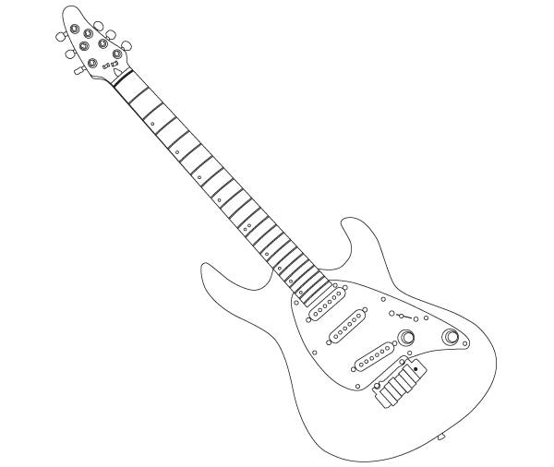

Time!
Can you improve your time?

Can you improve your
Score?

Jess says…
Try these x6 at Home!

Name:
Date:
Go tell your teacher how well you did!

