30 ÷ 5= | 50 ÷ 5 = | 12 X 5 = | 8 X 5 = | 45 ÷ 5=
3 X 5 = | 20 ÷ 5 = | 60 ÷ 5 = | 15 ÷ 5 = | 5 x 7 =
15 ÷ 5 = | 5 x 6 = | 5 X 5 = | 40 ÷ 5= | 5 ÷ 5=
55 ÷ 5 = | 11 X 5 = | 5 X 10 = | 60 ÷ 5= | 10 ÷ 5 =
35 ÷ 5= | 25 ÷ 5 = | 5 X 5 = | 9 X 5 = | 2 X 5 =
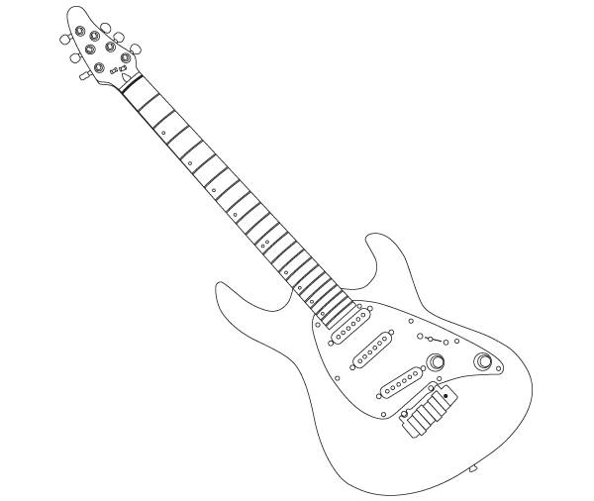

Time!
Can you improve your time?

Can you improve your
Score?

pete says…
Try these at
HOME
X÷5

Name:
Date:
Go tell your teacher how well you did!
Score:

