18 ÷ 6 = | 6 X 6 = | 6 X 11 = | 6 X 8 = | 6 ÷ 6=
6 X 3 = | 24 ÷ 6 = | 12 ÷ 6 = | 60 ÷ 6= | 6 X 8 =
6 X 7 = | 60 ÷ 6 = | 48 ÷ 6= | 36 ÷ 6= | 54 ÷ 6=
6 X 12 = | 6 X 10 = | 66 ÷ 6 = | 18 ÷ 6 = | 72 ÷ 6 =
42 ÷ 6= | 30 ÷ 6 = | 6 X 2 = | 6 X 2 = | 6 X 2 =
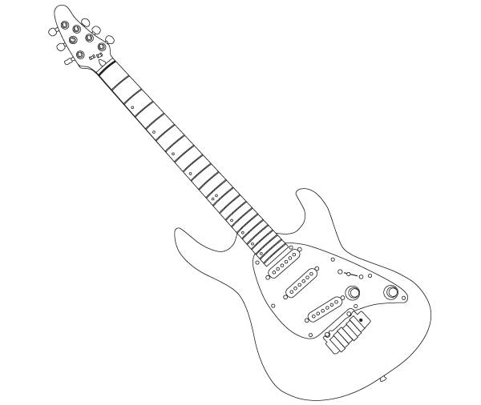

Time!
Can you improve your time?

Can you improve your
Score?

Jess says…
Try these x÷6 at Home!

Name:
Date:
Go tell your teacher how well you did!

