8 X 4 = | 80 ÷ 8 = | 8 X 12 = | 8 X 8 = | 72 ÷ 8=
8 X 3 = | 32 ÷ 8 = | 96 ÷ 8 = | 24 ÷ 8 = | 8 X 7 =
24 ÷ 8 = | 8 X 6 = | 48 ÷ 8= | 64 ÷ 8= | 8 ÷ 8=
8 X 12 = | 8 X 2 = | 8 X 10 = | 96 ÷ 8= | 16 ÷ 8 =
56 ÷ 8= | 40 ÷ 8 = | 8 X 5 = | 8 X 9 = | 88 ÷ 8 =
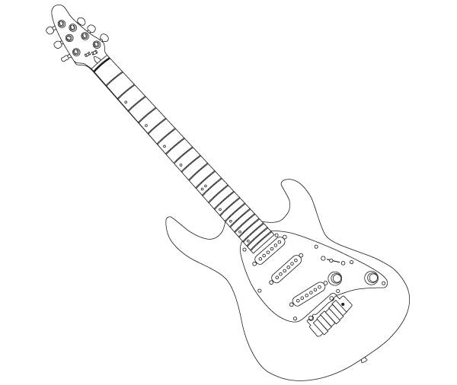

Time!
Can you improve your time?

Can you improve your
Score?

Tina says…
Try these x÷8 at home!

Name:
Date:
Go tell your teacher how well you did!

